Year 5 and 6

Oracy

- Prepare and practise a simple conversation re-using familiar vocabulary and structures in new contexts

Children are given practice in using a variety of questions and answers, and in creating spoken sentences that include nouns, verbs, adjectives, adverbs, conjunctions and prepositions.

- Understand and express simple opinion

Children have opportunities to express annoyance, surprise, disappointment and joy, as well as likes and dislikes when talking about food.

- Listen attentively and understand more complex phrases and sentences

Children have frequent opportunities to listen to:
- story books, in order to sustain the skill of listening to narrative in a social setting;
- non-fiction texts about the universe, linking to Science Unit 5E on Earth, Sun and Moon and to the Music Unit 18 Journey into space;
- sets of instructions in sequential steps for making origami planes and boats;
- songs by Henri Dès, used as background music for games or short physical or kinaesthetic activities and as a resource for linguistic progression;
- songs by France Gall, used as background music for daily keep-fit routines, encouraging the children to be active to music, linking with Science Unit 5A Keeping Healthy;
- traditional French songs.

Children also have the opportunity to watch a short film on DVD - L’enfant au grelot - with a French soundtrack and optional French subtitles.

- Prepare a short presentation on a familiar topic

Children have opportunities to memorise and recite a selection of short, spoken texts, e.g. a short story or section of a story, a short piece of non-fiction text on an aspect of the universe, a set of origami instructions, a song by Henri Dès, a song by France Gall, a traditional song, a shopping list and a description such as a scene that they can see or hear.

Literacy

- Re-read frequently a variety of short texts

Children have opportunities to re-read a range of fiction and non-fiction texts, traditional songs and songs by Henri Dès and France Gall. Children become increasingly with the full range of phonemes and graphemes and enabling them to pronounce and spell syllables, words, phrases and sentences.

- Make simple sentences and short texts

Children have opportunities to create in written form some of the sentences that they practise orally, using nouns, verbs, adjectives, adverbs, conjunctions and prepositions. They use writing frames and develop experience through dictation exercises.

- Write words, phrases and short sentences, using a reference source

Children continue to develop dictionary skills, learning how to use a more sophisticated dictionary and to understand the key elements of a bilingual dictionary entry. They use a dictionary regularly in order to check spellings, identify phonetic spellings, identify word classes and find translations.

Intercultural Understanding

- Compare symbols, objects or products which represent their own culture with those of another country

Children have opportunities to learn about and to sample French food in a social setting, especially appetisers eaten with bread and fresh raw vegetables, linking with Science Unit 5A Keeping Healthy.

They identify traditional regional products such as bottled water from France and the UK, Vichy pastilles, Nougat de Montelimar, Harrogate Toffee and Grasmere Gingerbread.

They become familiar with the currencies of France and the UK: the Euro and Sterling.

They have opportunities to learn and perform traditional French dances as well as folk dances from the UK - which links with Dance Activities in the primary PE curriculum.

They continue to learn traditional French songs, and have opportunities to learn and perform traditional folk songs from across the UK, which can help to provide a basis for Music unit 19: Songwriter - Exploring lyrics and melody.

They become familiar with the music of Erik Satie, and with paintings by the artists Gaugin, Manet and Pissaro.

They have opportunities to listen to music written by classical composers of the UK, such as Vaughan Williams, Stanford and Elgar.

- Look at further aspects of their everyday lives from the perspective of someone from another country

Children prepare themselves to talk to a non-native speaker visiting the class, considering the communication skills needed when speaking, e.g. speaking slowly and clearly and the use of intonation and gesture. This scheme addresses and challenges stereotypical views of the world, such as focusing on the different ways in which people speak, and asks the children to imagine how visitors might feel when visiting their class. They consider an aspect of everyday life - sport - and how it is perceived within different groups and communities.

- Recognise similarities and differences between places
Children have opportunities to look closely at the French town of Vichy and its surroundings and to make comparisons with the Yorkshire Dales and with their own region or locality.

Using the Scheme of Work in Year 5

The Year 5 Scheme of Work is the third in the series of Catherine Cheater Schemes of Work for French in Key Stage 2. It consolidates and builds on what has been taught in the Years 3 and 4 Schemes of Work. They each provide teachers with a structure and a recommended set of resources through which the expectations of the Key Stage 2 Framework for Languages can be met. In order to make planning as easy as possible the entire scheme is included on an accompanying CD so that teachers can easily adapt the lessons and parcels.

Methodology

A broad methodology is indicated in the lesson plans and parcels, but if this does not fit in with the personal teaching style of the teacher it should be put aside so that the teacher can direct activities in his or her own way, while still thinking about what the children need to do.

Skills development

The emphasis in Year 3 is very much on developing listening skills, closely followed by speaking skills; this is why there is a clear focus on storytelling, finger rhymes and singing traditional songs.

In Year 4 the teacher continues to develop the children’s listening and speaking skills through storytelling, songs and finger rhymes. However, the emphasis now shifts to developing an understanding of basic French grammar such as knowledge of word classes, agreements and some verb forms.

In Year 5 and 6 there is a strong emphasis on the development of fundamental reading and writing skills rooted in phonics, and training in how to use a dictionary. The teacher uses story books, modern and traditional songs and non-fiction texts to sustain the development of oracy and literacy skills. The children have opportunities create complex spoken sentences and to write using writing frames, creating sentences with nouns, verbs, adjectives, adverbs and conjunctions.

Developing Reading Skills

A core focus in each lesson is the development of reading skills by means of a structured reading scheme. Throughout Years 5 and 6 the structured reading scheme will introduce all the phonemes together with all the spelling patterns. This aims to help the children to read all kinds of texts with accurate pronunciation and a degree of fluency.

In order to develop good intonation and enunciation the children continue to listen to story books and also start to read story books to others. In year 5 the children read stories to Year 3 children, and in Year 6 they read stories to Year 4 children.

The structured reading scheme in the core of Year 5 lessons is Méthode de lecture pour apprendre à lire pas à pas. The children are introduced to the phoneme, then to words, short phrases and sentences. In order to support the teacher in modelling the phonemes, words and sentences with accurate pronunciation, a PowerPoint presentation in included on the Year 5 Scheme of Work CD Rom which includes native-speaker sound files.
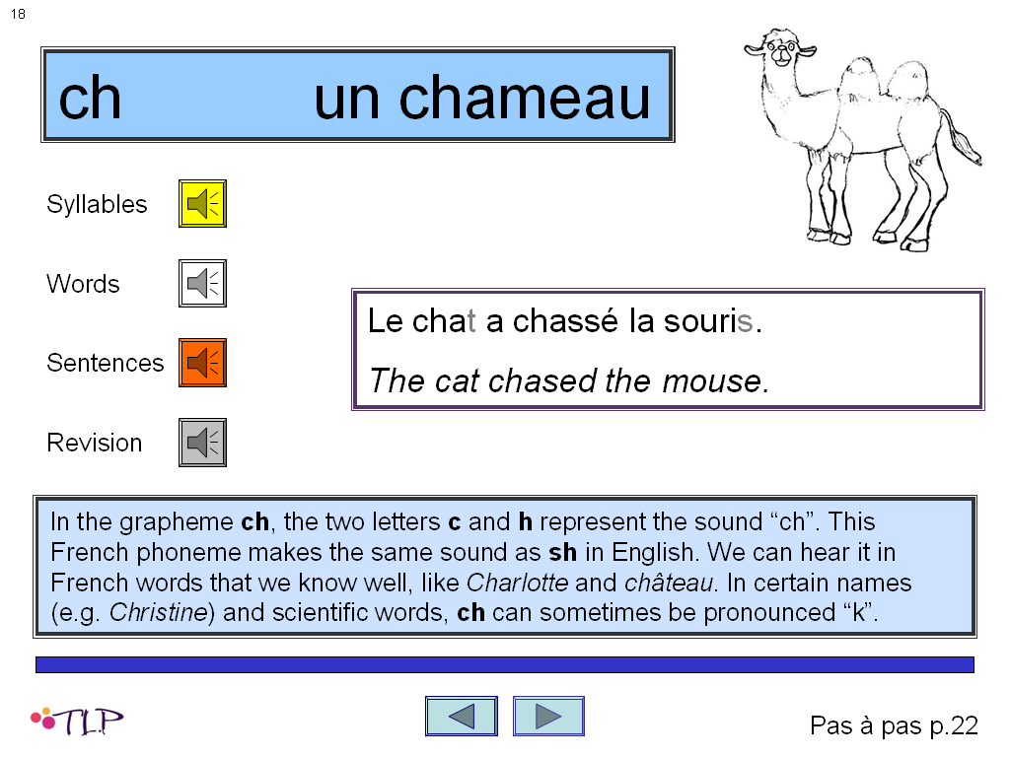
Information about the phoneme in French and links with English
An example of the phoneme used in a sentence

When using Méthode de lecture pour apprendre à lire pas à pas the children will need access to a copy of the book.

Some teachers might prefer to use Le Manuel Phonique to develop reading skills. In this case an alternative set of lesson plans and parcels can be printed from the CD, and a supporting PowerPoint with sound files is also available.

Linguistic Progression, vocabulary and sentence building

Although some core vocabulary is taught, children in Year 5 have a great deal of autonomy over their vocabulary learning. The vocabulary that is taught in lessons is carefully chosen and is used specifically to help the children develop word level and sentence level skills.

The children are now learning a large amount of vocabulary through other means: in songs (France Gall, Henri Dès), from DVD (Mon Âne, L’enfant au grelot), from the structured reading scheme, from story books, and from non-fiction texts such as L’Univers and Origami.

The children are also becoming more able to use a bilingual dictionary accurately, to look up the meaning of unfamiliar words.

The children have developed a core of vocabulary which they can identify by its word class. They are developing an increasing understanding of how to build simple and more complex sentences, and a clear understanding of syntax. Their sentence building skills are considerably enhanced by their exposure to story books and non-fiction texts since Year 3.

To support the class teacher in teaching vocabulary and sentence building skills, Language PowerPoints are included: Language PowerPoint 1 (Lessons 1 - 10), Language PowerPoint 2 (lessons 11 - 20) and Language PowerPoint 3 (Lessons 21 - 30). These provide instant templates for presenting and practising the language.

Dictionary Skills

In years 3 and 4 the children learned about the purpose of a bilingual dictionary, and developed the sequencing skills necessary for locating headwords, using a simple bilingual dictionary (e.g. Collins First Time French Dictionary).

In Years 5 and 6 they rely on a dictionary to help them find the meaning of unfamiliar words. The emphasis is on identifying and understanding each element of a dictionary entry so that they can find the information they need. They use a more sophisticated dictionary (e.g. Collins Pocket French Dictionary).

Planning

Overview - years 3, 4 and 5 at a glance

Strand | Year 3 | Year 4 | Year 5
Oracy | - Enjoy listening to and speaking in the language  - Listen and respond to familiar spoken words, phrases and sentences  - Communicate with others using simple words and phrases and short sentences  - Understand conventions such as taking turns to speak, valuing the contribution of others  - Use correct pronunciation in spoken work | - Listen to and identify words and short phrases;  - Communicate by asking and answering a wider range of questions;  - Memorise and present a short text. | - Prepare and practise a simple conversation re-using familiar vocabulary and structures in new contexts  - Understand and express simple opinions  - Listen attentively and understand more complex phrases and sentences  - Prepare a short presentation on a familiar topic
Literacy | - Recognise and understand some familiar words and phrases in written form  - Read aloud in chorus, with confidence and enjoyment, from a known text  - Write some familiar simple words using a model  - Write some familiar words from memory | - Read and understand familiar written phrases  - Follow a short text while listening and reading, saying some of the text  - Read a wider range of words, phrases and sentences aloud  - Write some familiar words and phrases without help | - Re-read frequently a variety of short texts  - Make simple sentences and short texts  - Write words, phrases and short sentences, using a reference source
Intercultural Understanding | - Appreciate the diversity of languages spoken within their school  - Talk about the similarities and differences of social conventions between different cultures  - Identify the country or countries where the language is spoken  - Have some contact with the country/countries  - Recognise a children's song, rhyme or poem well known to native speakers | - Talk about celebrations of which they have experience  - Know about similar celebrations in other cultures  - Compare aspects of everyday life at home and abroad  - Identify similarities in traditional stories, building on relevant Y2/3 National Literacy Strategy Framework objectives | - Compare symbols, objects or products which represent their own culture with those of another country  - Look at further aspects of their everyday lives from the perspective of someone from another country  - Recognise similarities and differences between places

Year 5

Term 1 | Term 2 | Term 3
Days of week  lundi, mardi, mercredi, jeudi, vendredi, samedi, dimanche  Months  janvier, février, mars, avril, mai, juin, juillet, août, septembre, octobre, novembre, décembre  Numbers 0-31  zero, un, deux, trois, quatre, cinq, six, sept, huit, neuf, dix, onze, douze, treize, quatorze, quinze, seize, dix-sept, dix-huit, dix-neuf, vingt, vingt et un, vingt-deux, vingt-trois, vingt-quatre, vingt-cinq, vingt-six, vingt-sept, vingt-huit, vingt-neuf, trente, trente et un  Masculine nouns eg  un canard, un chameau, un cheval, un crocodile, un dauphin, un escargot, un lapin, un loup, un merle, un poisson, un renard, un robot, un singe, un zèbre.  Feminine nouns eg  une biche, une chèvre, une coccinelle, une étoile, une fourmi, une pie, une tortue, une vache  Writing short sentences using adverb of place, nouns and adjectives  Eg. Dans le jardin il ya un grand renard rouge  Feminine agreement with noun and adjectives  Eg. Petite, grande, blanche, bleue | Adverbs of place/sentence starters  Eg. Dans le salon, Dans, le cuisine, Dan la piscine, Dans le poirier, Dans le garage  Verbs e.g.  aller, être  tricoter, chanter, nager, voler, sauter, danser  j’entends, je vois  je pense que/ qu’…  Infinitive form  Adjectives that precede the noun e.g.  Jeune, joli.  Writing short sentences using adverb of place, nouns, verbs and adjectives  Eg. Dans la cuisine, je vois une jeune souris bleue nage  Asking questions, e.g.  Où est la baleine ?  Que fait la coccinelle ?  Qu’est-ce qu’il fait ?  Est-ce que le canard tricote ?  Où va le lion ?  Le chat, qu’est-ce qu’il va faire ? | Expressions of annoyance, impatience, disappointment, frustration, disbelief, joy, disagreement, e.g.  Zut alors!  Mince alors!  Mais enfin!  Ça alors!  Tu rigoles!  C’est pas vrai!  C’est pas possible!  Non !  Tu plaisantes !  Tu rigoles !  Ce n’est pas sérieux !  Incroyable !  Vocabulary from text Loup, Loup, y-es tu ?  Questions  Items of clothing  Verbs e.g.  aller, être  tricoter, chanter, nager, sauter, danser, chanter  j’entends, je vois  je pense que/ qu’…  Relative pronoun  qui (e.g. un cochon qui chante)  Subject pronouns, e.g.  je, tu, il, elle, ils, elles

Year 6

Term 1 | Term 2 | Term 3
Revision of days, months, greetings, personal information  Eg. Je m’appelle.. J’ai…ans, J’habite… J’ai un frère…, J’ai un chien  Conjunctions  Et, aussi  Numbers 32 - 60  trente-deux, trente-trois, trente-quatre, trente-cinq, trente-six, trente-sept, trente-huit, trente-neuf, quarante, quarante et un, quarante-deux, quarante-trois, quarante-quatre, quarante-cinq, quarante-six, quarante-sept, quarante-huit, quarante-neuf,  cinquante, cinquante et un, cinquante-deux, cinquante-trois, cinquante-quatre, cinquante-cinq, cinquante-six, cinquante-sept, cinquante-huit, cinquante-neuf, soixante.  Counting in steps of 5 and 10  5 x table in French  France as a country  Geography of country - location in world/Europe, borders and oceans, size, population, main economies, landscape : mountain ranges, rivers, main cities, famous French people, famous landmarks | Numbers 0-100  Simple calculations : moins, plus  Counting in steps of 5 and 10  3x table in French  Adverbs of time/ freqency  aujourd'hui, maintenant, souvent, quelquefois, à + time on the clock  Telling the time  Quelle heure est-il ?  Il est une heure, deux heures, trois heures, quatre heures, cinq heures, six heures, sept heures, huit heures, dix heures, neuf heures, onze heures… et demie.  Il est midi, il est minuit… et demi.  Subjects at school  Eg. L’anglais, le français, l’histoire, la géographie, le théâtre, les mathematics, l’informatique, la musique, les sciences, le dessin, les sports  Expression opinion e.g.  j’aime, je n’aime pas + noun, c’est (très) bon, c’est intéressant, j’adore, je déteste  Conjunction  Mais  Subject pronouns, e.g.  je, tu, il, elle, ils, elles  Disjunctive pronouns, e.g.  moi, toi, lui, elle | Sports  Eg, le hockey, le hockey sur la glace, la natation, la gymnastique, l’équitation, l’athletisme, le cyclisme, le judo, le foot, le basket, le ping pong, le golf, le rugby  Expression opinion e.g.  j’aime, je n’aime pas + noun, c’est (très) bon, c’est vite, j’adore, je déteste  French food e.g.  aioli, tapenade, rillettes de saumon, pâté de canard au poivre vert, bonbons au miel, galettes bretonnes, nougat de Montelimar, sirop de fruits  Healthy food e.g.  le céléri, le concombre, les carottes, les olives, les radis, les tomates  Fruits, vegetables and sweet foods  Conjunction  mais  French Breakfast  Je voudrais, croissant, une tranche de baguette, la confiture de la fraise, avec du chocolat, un lait au chocolat froid, un eau, un jus d’orange  Manners  Merci, merci beaucoup, s’il vous plâit, non merci, oui, non,

