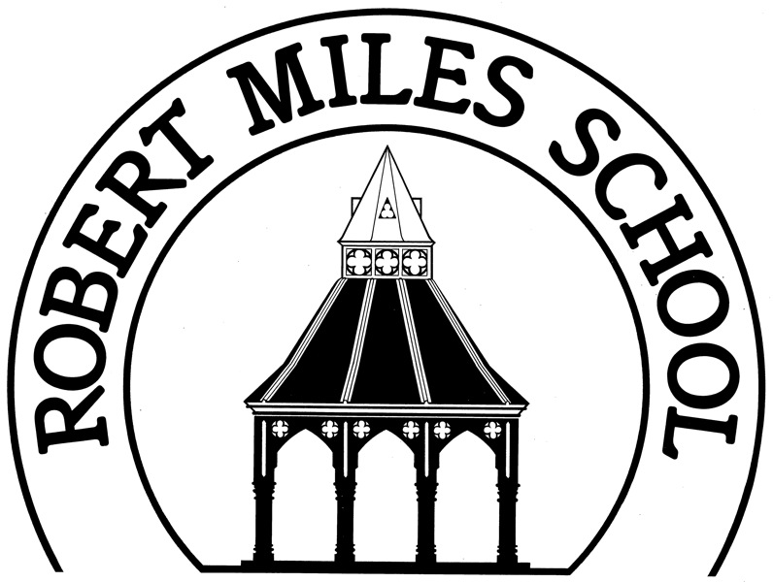
Robert Miles Junior School
Market Place, Bingham, Nottingham NG13 8AP

Dear Parents/Carers,
In order for us to have an up-to-date record of details relating for your child, could you please complete the form below and return it to school as soon as possible. As you will appreciate, this information is required urgently in the event of an accident occurring. If we need to contact you urgently for any reason about your child we will phone the people in the emergency contact list in the order you have listed them.
The information requested in this document will be treated as strictly confidential by the professional staff concerned with your child’s education. We are happy to assist you with filling out any part of the form.
Robert Miles Junior School has a duty to protect personal information belonging to the public whom it serves. Robert Miles Junior School is notified under the General Data Protection Regulation (GDPR) and is committed to all its principals and adheres to the ‘Best Practice’ in data security. The information we receive will be shared (under statutory requirements) with Local Education Authorities and the DfE for statistical analysis. If any safeguarding concerns are raised by the completion of this form the appropriate authorities will be contacted.

ROBERT MILES JUNIOR SCHOOL: CONTACT AND INFORMATION FORM
Child’s full name:
Date of birth: Gender:
Address:

Post Code:
Home tel:
Parents/Carers with whom the child lives at the above address
Name: |  | Name:
Mobile: |  | Mobile:
Work Tel no: |  | Work Tel no:
Email: |  | Email:
Relationship to child: |  | Relationship to child:
Parental responsibility: [ ] Yes [ ] No |  | Parental responsibility: [ ] Yes [ ] No
Member of HM Forces: [ ] Yes [ ] No |  | Member of HM Forces: [ ] Yes [ ] No
Emergency contacts
If we need to contact you during the school day we will use the numbers listed below in the order you have recorded them:
1st contact number: |  | Name:
2nd contact number: |  | Name:
3rd contact number: |  | Name
4th contact number: |  | Name:
Other parents
In the case of separated or divorced parents please enter here the name and address of the parent whose details were not given previously. Please indicate if they do/do not have parental responsibility.
(Where parents were married at the time a child was born both parents have parental responsibility in law, even if not living with the child. Others may acquire parental responsibility through joint registering of birth, subsequent marriage or court arrangements.)
Name: |  | Name:
Address:  Postcode: |  | Address:  Postcode:
Telephone number: |  | Telephone number:
Relationship to child: |  | Relationship to child:
Parental responsibility: [ ] Yes [ ] No |  | Parental responsibility: [ ] Yes [ ] No
Does he/she require a copy of reports: [ ] Yes [ ] No |  | Does he/she require a copy of reports: [ ] Yes [ ] No
Other relevant information
Is your child subject to any court order? : [ ] Yes [ ] No
If yes, please give brief details and bring a copy to school for our records.

Is there anything else that it would be helpful for school to know about your child’s residency and access arrangements?

Language, Ethnicity and Religion
Language spoken at home  [ ] English  [ ] Hindi  [ ] Gudjurathi  [ ] Punjabi  [ ] Urdu  [ ] Spanish  [ ] Portuguese  [ ] Turkish  [ ] Polish  [ ] Tamil  [ ] Other – please state  _______________________ | Child’s first language  [ ] English  [ ] Hindi  [ ] Gudjurathi  [ ] Punjabi  [ ] Urdu  [ ] Spanish  [ ] Portuguese  [ ] Turkish  [ ] Polish  [ ] Tamil  [ ] Other – please state  _______________________ | Ethnicity  [ ] White UK Heritage  [ ] White European  [ ] Black Caribbean Heritage  [ ] Black African Heritage  [ ] White and Black Caribbean  [ ] White and Black African  [ ] Indian  [ ] Pakistani  [ ] Bangladeshi  [ ] Chinese  [ ] Other – please state  _______________________ | Religion  [ ] Church of England  [ ] Anglican  [ ] Methodist  [ ] Baptist  [ ] Roman Catholic  [ ] Hindu  [ ] Muslim  [ ] Jewish  [ ] Sikh  [ ] No religion  [ ] Other – please state  _______________________
Medical/Other relevant information
Name and telephone of family doctor:
Does your child suffer from any chronic/sever allergies (e.g. nuts, wasps, etc) or any other conditions whereby he/she may require medication to be given whilst in school? If so, please give details

If your child requires medication to be given during school hours, please call at the office for a “Consent Form for the Administration of Drugs”.
Does your child have any problems with hearing or sight? [ ] Yes [ ] No (If yes please give details)
Is your child on regular medication? [ ] Yes [ ] No (If yes please give details)
Is your child allergic to plasters? [ ] Yes [ ] No
Are there any other professionals who help your child? (E.g. speech therapist, health visitor, paediatrician, etc) [ ] Yes [ ] No (If yes, please give details)
Please write any other medical information below which you think it is important for us to know e.g. asthma, illnesses, fears, physical or emotional problems
Special Educational Needs
Has a statement of Special Educational Needs or Educational, Health and Care Plan been issued in respect of your child? [ ] Yes [ ] No (If yes please give brief details)
Does your child have any Special Educational Needs ? [ ] Yes [ ] No
If yes, please give brief details. If your child has any form of Special Educational Needs please arrange an appointment with Mrs C. Ward, our SENCO, to discuss our school’s support of your child in more detail.
School Meals
Are you eligible to apply for free school meals? [ ] Yes [ ] No [ ] Don’t know
(Families who receive certain benefits may be eligible for free school meals. Your child is eligible for free school meals if you’re in receipt of one of the following benefits:
- Universal Credit with an annual net earned income of no more than £7,400.
- Income Support
- Income-based Jobseeker’s Allowance
- Income-related Employment and Support Allowance
- Support under Part 6 of the Immigration and Asylum Act 1999
- The guarantee element of Pension Credit
- Working Tax Credit run-on (paid for the four weeks after you stop qualifying for Working Tax Credit)
- Child Tax Credit (with no Working Tax Credit) with an annual income of no more than £16,190
If your child is eligible for free school meals they will also benefit from reduced costs on school trips, residential visits etc. It is important for the school that you register your child for free school meals if you can, even if your child will not be having school dinners)
I would like further information about how to apply for free school meals: [ ] Yes [ ] No
Texting Service and Email
The school uses a text messaging service where we can register one mobile number per child. Please indicate here which mobile phone number you wish to register for this service:
Text message mobile number:
The school also send out Newsletters and other information via email. We can register as many emails per child for this service as you wish. Please list below the email address(es) you wish to register for this service:

Details of person completing form
Full name: | Relationship to child:
Signed: | Date:

If any information you have given in this form should change during the school year, please contact the school so we can update our records.
ROBERT MILES JUNIOR SCHOOL: PERMISSION SLIPS
Name of child..................................................................................... Class………………………….
Swimming/Local Visits
Robert Miles Junior School children are able to go swimming regularly at Bingham Leisure Centre and walk to the pool. Children may also visit local places of interest during school hours e.g. the church, the library, which are within walking distance.

I give my permission for my child to walk to swimming/visit places of local interest.

Signed: ………………………………………………………………………… Date……………………………………………….
Photograph Permission
There are many activities and occasions in school where children are likely to be photographed/filmed to record their achievements and success and to complement the work they do. As a parent/carer you have the right to decide whether you wish to give consent to your child’s image being captured during such an activity.
Internal Activity
1. We may take photographs of the children to use for internal purposes, for example display boards at school, using film in the curriculum or other educational reasons.
Whenever there are events to which we invite parents and other family members (plays, sports days, special assemblies etc) we will allow photographs/video footage to be taken, but we ask everyone to ensure these photographs/videos are for personal/family use and will not be posted on the internet or social media.
External Activity
2. The school may also post images to the school website and include them in the school Newsletters. When we do this, we will never use a child’s full name, in line with our Use of Children’s Photographs Policy.
3. From time to time, our school will be visited by the media or other invited agents who may take photographs/film footage or carry out newspaper/radio/television interviews and names of the child may be mentioned in their publications.
Please indicate below your wishes for your child:
I am happy for my child to be photographed/filmed during an activity classed as Internal No.1 [ ] Yes [ ] No
I am happy for my child to be photographed/filmed during an activity classed as External No.2 [ ] Yes [ ] No
I am happy for my child to be photographed/filmed during an activity classed as External No.3 [ ] Yes [ ] No
I am happy for my child to be photographed/filmed at a local event, such as a sporting competition, choir concert, dance display etc and for these pictures to be shared with the other schools taking part. [ ] Yes [ ] No
I agree that any photograph or video I take at a school event with children other than my own child will be for personal/family use and will not be posted on the internet or shard on social media [ ] Yes [ ] No

Signed: ………………………………………………………………………… Date……………………………………………….

