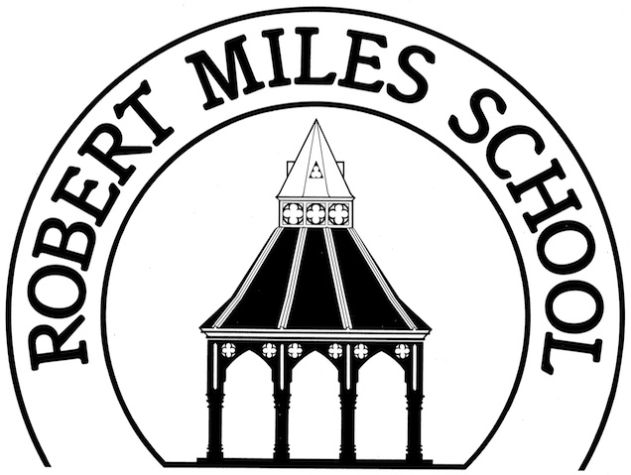

E-Safety Policy

Policy Updated: | September 2024
Date for Review: | Summer 2026

Aims and Objectives
The use of the Internet at Robert Miles Junior School aims to:
- Raise educational standards
- Promote pupil achievement
- Support the professional work of staff
- Enhance the school’s management information and business administration systems
Internet use is a part of the statutory curriculum and a necessary tool for staff and pupils. Internet access is an entitlement for students who show a responsible and mature attitude.

The Benefits of the Internet
Access to the Internet is beneficial in school because it offers:
- Access to world-wide educational resources including museums and art galleries
- Educational and cultural exchanges between pupils world-wide
- Access to professional bodies and experts in many fields for pupils and staff

Internet Content
The school Internet access will be designed expressly for pupil use and will include filtering and be appropriate to the age of pupils. Staff will guide pupils through safe online activities that will support the learning outcomes planned for the pupils’ age and maturity. Pupils will be educated in the effective use of the Internet.
The school will where possible ensure that the use of Internet derived materials by staff and by pupils complies with copyright law. Older pupils should be taught to be critically aware of the materials they read and shown how to validate information before accepting its accuracy.

Internet Access Authorisation

Staff
All staff including teachers, supply staff, teaching assistants, support staff and administrative staff will have access to the School Internet Policy, and its importance explained. Staff should be aware that Internet traffic can be monitored and traced to the individual user. Discretion and professional conduct are essential.

Pupils
The school allows Internet access to all pupils. Key Stage 2 pupils will use the Internet with greater independence than at Key Stage 1 and will be taught to use the Internet safely and effectively.

Computing System Security
The school computing systems will be reviewed regularly with regard to security and any LA / DFE guidance will be adopted.
- The use of data sticks and any other data recordable devices, except by staff or with their express agreement, will not be allowed in school
- Only authorised technicians will be able to introduce and install new programs onto the network

Online Security and Safeguarding
Online security to protect and safeguard children’s access to inappropriate websites and images is maintained through the following ways:
- Filters managed by the school’s internet and IT provider restrict flagged (inappropriate) images and websites from entering into the school domain – children are blocked from clicking on sites that are not suitable for their viewing.
- Where inappropriate images/websites/language are accessed, the Headteacher is immediately alerted through an automated system. The Securly Filtering software is currently used by the school.

Inappropriate Websites
If staff or pupils discover inappropriate or unsuitable websites, the URL (address) content must be reported to the Internet Service Provider via the school office.

Email
Pupils may only use the approved school email accounts on the school system.
When using email:
- Pupils must be supervised
- Pupils are instructed to immediately tell a teacher if they receive offensive emails
- Pupils are instructed not to reveal personal details of themselves or others (e.g. home address or telephone number) or arrange to meet anyone in email communication

Teaching Internet Safety
In all year groups, children will be taught the importance of e-safety with regards to sharing information and communicating online. This includes gaming, social media sites, using webcams and texting on mobile phones. E-Safety needs constant reminders and should not just be taught once a year. It is covered in PSHE lessons, assemblies and computing lessons.
The school uses and promotes the SMART rules taken from the Childnet website. http://www.childnet.com/young-people/primary
We will work closely with our parents to share our knowledge of the on-line issues faced by children, providing a signpost to resources to help them have open conversations with them at home.

Internet Chatrooms
Pupils will not be allowed access to public or unregulated chat rooms. Children should use only regulated educational chat environments where an educational benefit has been established. If used, this will always be supervised and the importance of chat room safety emphasised. Newsgroups will not be made available unless an educational requirement for their use has been demonstrated.

Inappropriate Material
In common with other media such as magazines, books and video, some material available via the internet is unsuitable for pupils. The school will take all reasonable precautions to ensure that users access only appropriate material. However, due to the international scale and linked nature of internet content, it is not possible to guarantee that unsuitable material will never appear on a school computer.

Emerging Internet Uses
Emerging technologies will be examined for educational benefit and a risk assessment will be carried out before use in school is allowed.

School Website
Robert Miles Junior School’s new website provides comprehensive information about school life including contact details such as the school address, school email and telephone number.
The following will NEVER be included on the school website:
- Staff, pupils’ and Governors’ home information will not be published
- Where a photo contains an easily identifiable individual, that child will only be referred to by their initials. Pupils’ full names will not be used anywhere on the website.
- Children’s work will only be identified by first name and / or year group or their initials.
Robert Miles Junior’s Photograph Policy enables Parents / Carers to be given the opportunity to state whether photographs of their child may or may not be published on the school website. The school then acts on this information. The school will keep a record of all pupils who do not have consent for use of their photographs on the school website. This is in line with Robert Miles Junior’s Safe Use of Children’s Photographs Policy.

Tablets and iPads
Pupils must be supervised at all times when they are using tablets and iPads. Children should not be allowed to use the devices during unstructured times such as wet playtimes. Children are instructed not to change any settings on the tablets or iPads. Children must not download games or apps on to the devices unless asked to do so by a teacher.

Mobile Telephones
Pupils will not be allowed mobile phones during school time. Any mobile phones brought into school should be kept in the School Office or safely with the class teacher during the school day. The sending of abusive or inappropriate text messages is forbidden.
For further details regarding the use of mobile phones within Robert Miles Junior School, please see the school’s policy on the Acceptable use of Mobile Phones, Cameras and Recording Devices.

Complaints
Responsibility for handling incidents will be delegated to a senior member of staff.
Any complaint about staff misuse of school computing systems or the internet must be referred to the Headteacher.
Parents will be informed should a pupil misuse school computing systems or the Internet.

Information for Parents
Information and support for parents can be found at https://www.thinkuknow.co.uk/parents. The school includes E-Safety information for parents in the weekly newsletter.

Equality, Diversity and Inclusion
At Robert Miles Junior School, we aim to ensure that no member of the school community experiences harassment, less favourable treatment or discrimination within the learning environment because of their age; any disability they may have; their ethnicity, colour or national origin; their gender; their religion or beliefs.
We value the diversity of individuals within our school and do not discriminate against anyone because of ‘differences’. We believe that all our children matter and we value their families too. We give our children every opportunity to achieve their best by taking account of our children’s range of life experiences when devising and implementing school policies and procedures.

Policy Review
This policy will be regularly reviewed by the Governing Body and updated in line with Robert Miles Junior School’s Policy Schedule.

